Vatslav Zhdanovich 1160737
Vkz001@student.uscedu.au
Task 3: Text-Based GAme
ICT112: Programming Fundamentals

Table of Contents
1 Problem Description 1
2 Pre-development 2
3 Development and Design 4
4 Post-development 8

Table of Figures

Figure 1: menu() function 4
Figure 2: mainLoop() function 4
Figure 3: action() function match case 5
Figure 4: action() function checking input 5
Figure 5: Player class attributes 6
Figure 6: Player class methods 6

Problem Description
The game follows you, a student at UniSC. When the game begins, the player is placed in a randomly selected room, where they need to complete their workshop. They are then instructed to go to their exam, located in another room. Before reaching the exam room, the player must locate their laptop, and collect a drink. The player controls their character by using the keyboard to input commands. The condition for game completion is that the player reaches the correct room with the correct items in their inventory. In order for the player to meet this condition they will have to navigate the campus using compass directions and complete tasks in order to gain access to other rooms. The player’s final score will be determined by how many tasks they complete, with a special item being obtainable which grants the player a boost in score.

Pre-development
Prior to commencing development, a plan was drafted to generate the scope of the game. The plan plans what features the game needs to meet the requirements of the task, how solutions will be implemented, as well as the general framework of the game. Using this, pseudocode was written to gain a better understanding of the requirements (fig.1). Pseudocode was written in Microsoft Visual Studio Code because using a word processer (e.g. Microsoft Word, Google Docs) proves to be tedious, as the automatic formatting, capitalisation and grammar checks interfere when trying to write pseudocode.
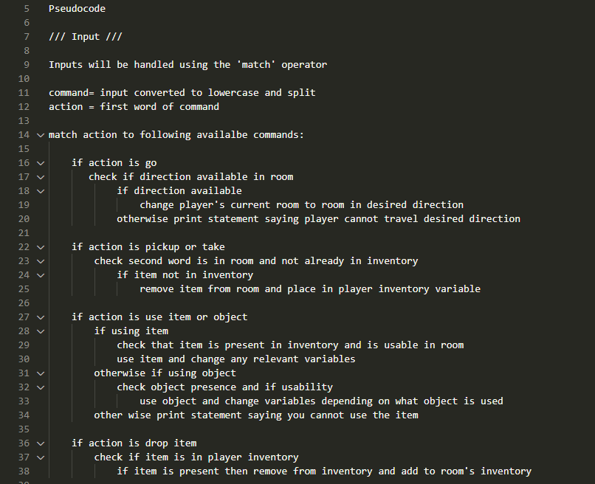
Figure 1: Psuedocode example

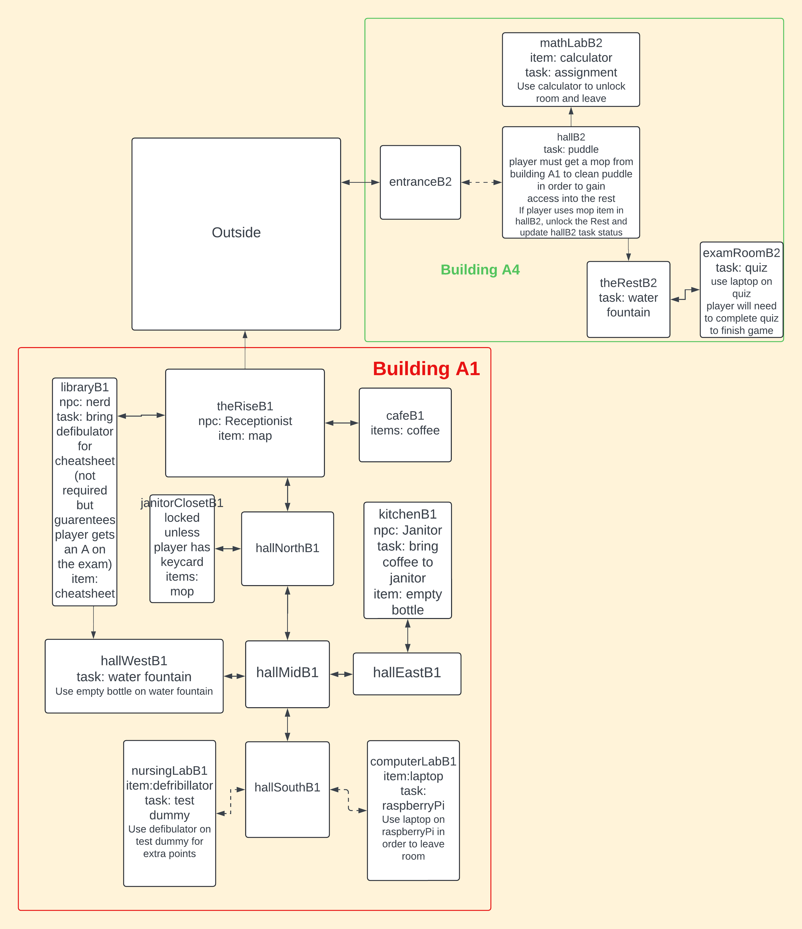
After the pseudocode was created, a plan of the rooms was created using LucidChart (https://www.lucidchart.com). The room plan outlines the attributes and paths of each room (fig.2). This was done because to visualises the game in a convenient manner. Using the room plan, coding the game is made easier by being able to see what is required of each room. Additionally, the room plan was used to create a map of the campus, to be used by the program when called.
Figure 2: Room map

Development and Design
Room Structure
The game features 18 rooms to navigate. This meets one of requirements for the advanced solution, stipulating 15 rooms. Each navigable area is defined as a room (so outside is technically a room). This was done to streamline player movement commands, as well as the requirement the game accept compass directions as navigation.

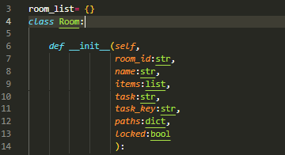
Rooms are defined as objects, with class ‘Room’ . This way, new rooms may be added by defining the values. The attributes of each room are defined in the roomData.py file, when each room is initialized. Room objects have no methods, in order to not cause confusion. When the room is initialized it automatically adds itself to a list of all other room objects. This is done so the player’s room can be set as the room object, as initial tests would set the room to a string describing the room object,
Figure 3: Room class

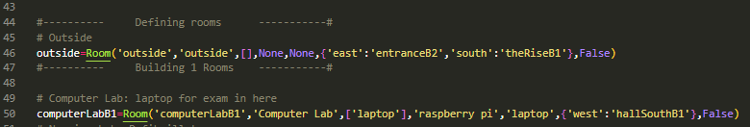
Rooms are created manually. These attributes are used by the player methods to determine what the player is able to do. The main problem with this is there is little margin for error, as everything must be in the correct position otherwise the game may not work. Additionally, the room’s descriptions (along with all other descriptions) are defined in a dictionary, in a separate file. This is done so the text may be edited without disturbing the rest of the code.
Figure 4: Defining rooms

Game loop
Before anything happens, the clear() function ( os.system(‘cls’) ) is called to clear the screen of previous messages that may have appeared. Next the menu() function is called (fig.3). Before prompting input, the controls of the game are printed for the player to read. The player is then prompted to type ‘start’ to begin the game.
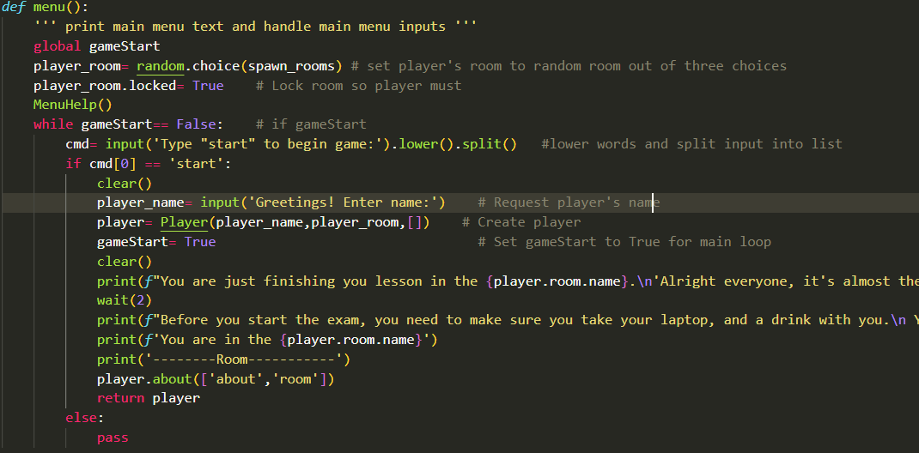
The game is then initialized when the player inputs a name.
Figure 5: menu function

After player is defined, the mainLoop().function is called (fig.4). This function is responsible for keeping the game running until the exam is complete. This is accomplished by using a while loop. The loop is begun by the player when they enter a command. The command is then formatted to be lowercase, and the string is split into individual words using the .lower() and .split() methods. The loop checks if the input is not null, before passing the command to the action() function.
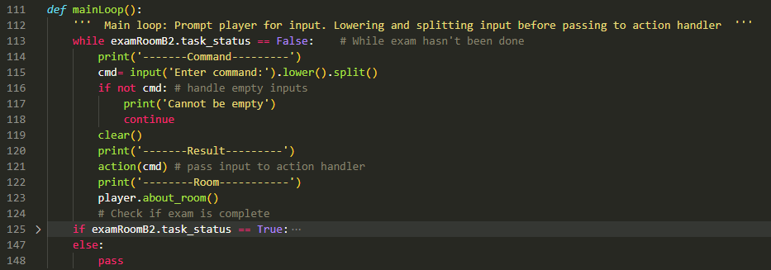
Figure 6: Main loop

The action() function processes the command by first checking if the input is indeed not empty. Next the input is passed through an if statement to see if it any of the single word commands (help, hint, quit) (fig.5). If the input passes to the else statement, the first word of the input is selected to be matched to a case (these are the available commands).
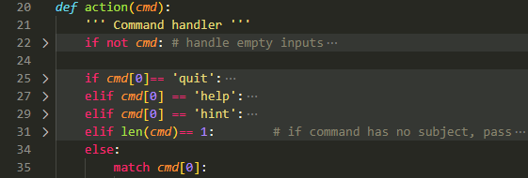
Figure 7: Input processing
From here, depending on the first word of the command, the input is passed to the corresponding case, where is it then pass to the relevant player method (fig.6).
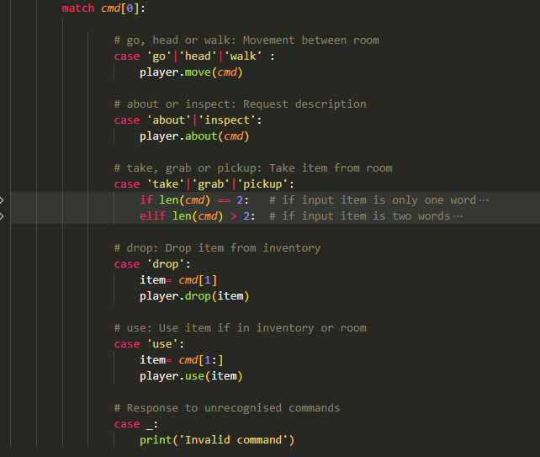
Player
Figure 8: match case for handling inputs
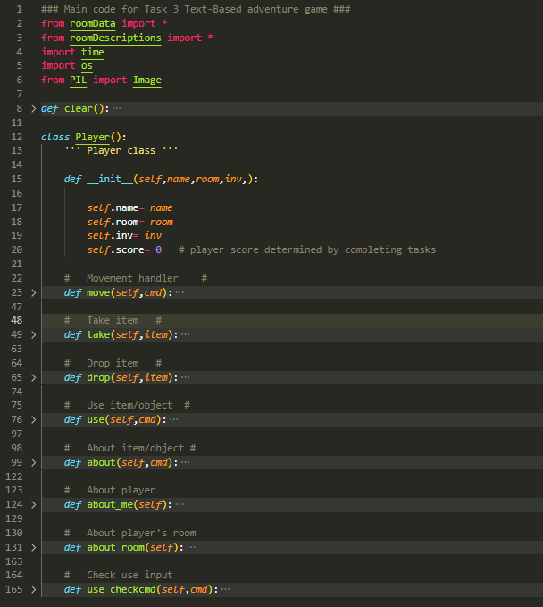
The player is defined as an object, with the attributes, name, room, inv and score (fig. 7). This provides an easy way to access variables, change attributes, and add methods.
Figure 9: Player class

Inputs from the player are processed by the action function in the game.py file, where it is determined which player method the input must be passed to (fig.8). After being passed to the relevant method, the input is processed, and an output is given.
Figure 10: Methods of player class

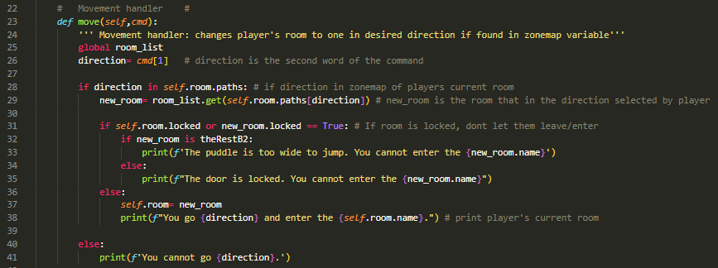
Using the move function as an example, the desired direction is checked to see if it exists in the player’s current room as a path. If the path does not exist, the program continues, and checks if the current room or the new room is locked. If the room is locked, then movement is rejected, and a statement is printing reflecting this.
Figure 11: movement example

Post-development

A main challenge was considering what to put in the rooms. As creating rooms was not challenging, 18 rooms were created. The problem arose when having thing to do in the rooms. As questions were not a condition for game completion, they were not implemented. Instead, the player is to complete tasks in order to obtain key items which help them reach the exam room.

Due to the way the game was developed, unit-testing was not considered until it was too late. Code was tested independently of the main game loop, however none of this was saved as it was not considered important at the time.

A flaw realised after the game was complete is that the descriptive statements are handled in manner that is confusing. In the effort to make the code more readable, the descriptions were placed in one file. The way these descriptions were retrieved required a description to exist, otherwise causing the game to crash.

There are a lot of improvements that could be made to the code, especially by implementing iteration, unit-testing and scripts. In general, the game does run, however many things could have been done different to ensure a more complete and optimised solution.

